**Phase 4: CI/CD Deployment for Springboot Application**

**Developer Details:**

Name: Kashyap Kalola

Email: [kashyap.kalola43@gmail.com](mailto:kashyap.kalola43@gmail.com)

Date created: 17-05-2022

Project Name: CI/CD Deployment for SpringBoot Application

GitHub Repository:

<https://github.com/KashyapKalola/AWS-DecOps.git>

**Project Background :**

**Project Objective:**

To build a CI/CD pipeline to demonstrate continuous deployment and host the application on AWS EC2 instance.

**Background of the problem statement:**

To automate the integration and deployment of the web application. Required to set up an environment where the application will be hosted and accessed by users. The source code is supposed to be fetched from a GitHub repository.

**Tools used for development:**

* Eclipse
* GitHub
* Jenkins
* AWS EC2/ Virtual machine

1. ECLIPSE: Eclipse is an integrated development environment used in computer programming. It contains a base workspace and an extensible plug-in system for customizing the environment. It is the second-most-popular IDE for Java

development, and, until 2016, was the most popular.

1. GITHUB: GitHub, Inc. is a provider of Internet hosting for software development and version control using Git. It offers the distributed version control and source

code management functionality of Git, plus its own features.

1. JENKINS: Jenkins is an open-source automation server. It helps automate the parts of software development related to building, testing, and deploying, facilitating continuous integration and continuous delivery. It is a server-based

system that runs in servlet containers such as Apache Tomcat.

1. AWS EC2: Amazon Elastic Compute Cloud is a part of Amazon.com's cloud-computing platform, Amazon Web Services, that allows users to rent virtual computers on which to run their own computer applications.

**Sprint Table:**

|  |  |  |  |
| --- | --- | --- | --- |
| SPRINT | WORK DONE | TIME PERIOD | RESULT |
| 1 | Created a SpringBoot Apllication | 10/05/2022 | Done ✓ |
| 2 | Created a Jenkins Job and Build PipeLine | 11/03/2022 to 12/05/2022 | Done ✓ |
| 3 | Created EC2 Instance | 13/05/2022 to 14/05/22 | Done ✓ |
| 4 | Runs SpringBoot Application on EC2 | 15/05/22 to 16/05/22 | Done ✓ |

**ScreenShots of Application**

SpringBoot Application :-

Create a simple spring boot application and using Rest API, run the application on local host using inbuilt tomcat server.

Do a Maven Build and generate the jar file.

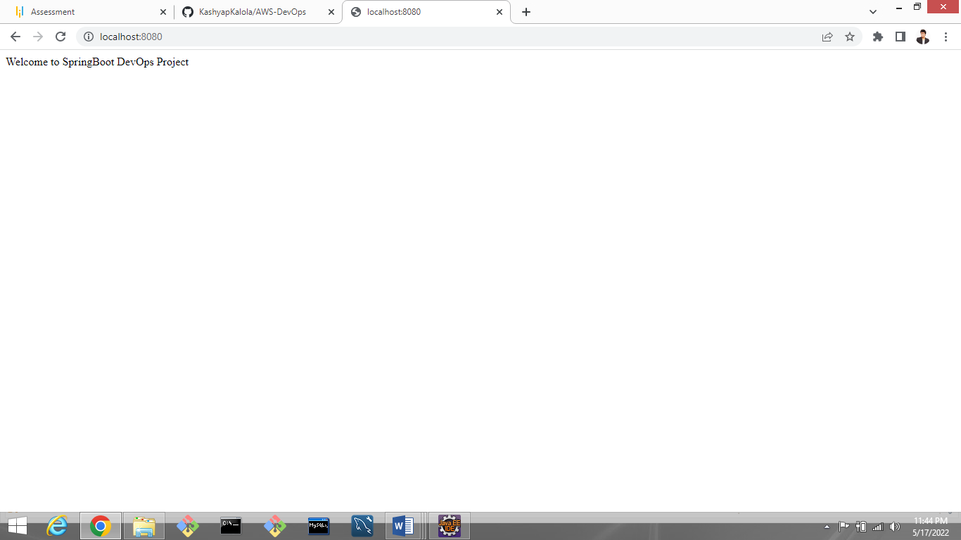

Push this code in Git Repository :-

Create a GIT reposirotry and push that springboot application and commit the latest changes.

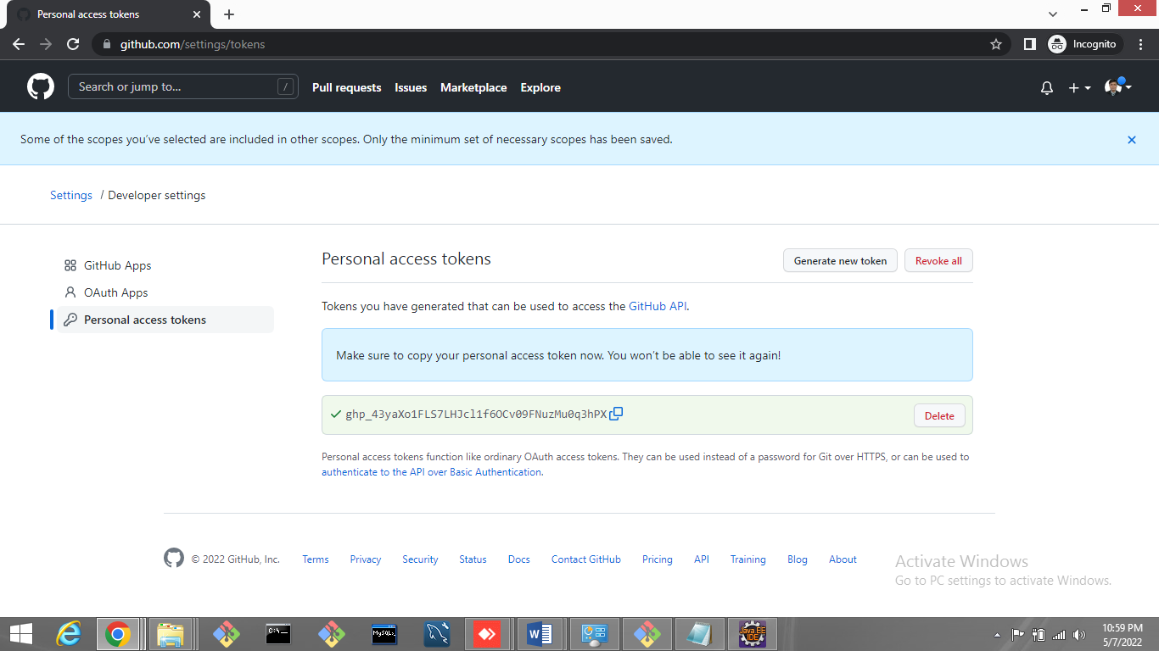

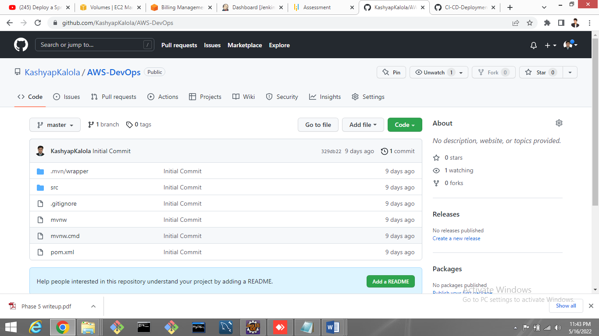

Build a Jenkins Pipeline :-

Create a Jenkins Job using appropriate configuration and dependency then run its instance on port 8081.

Also build the job using Git repository and create pipeline.

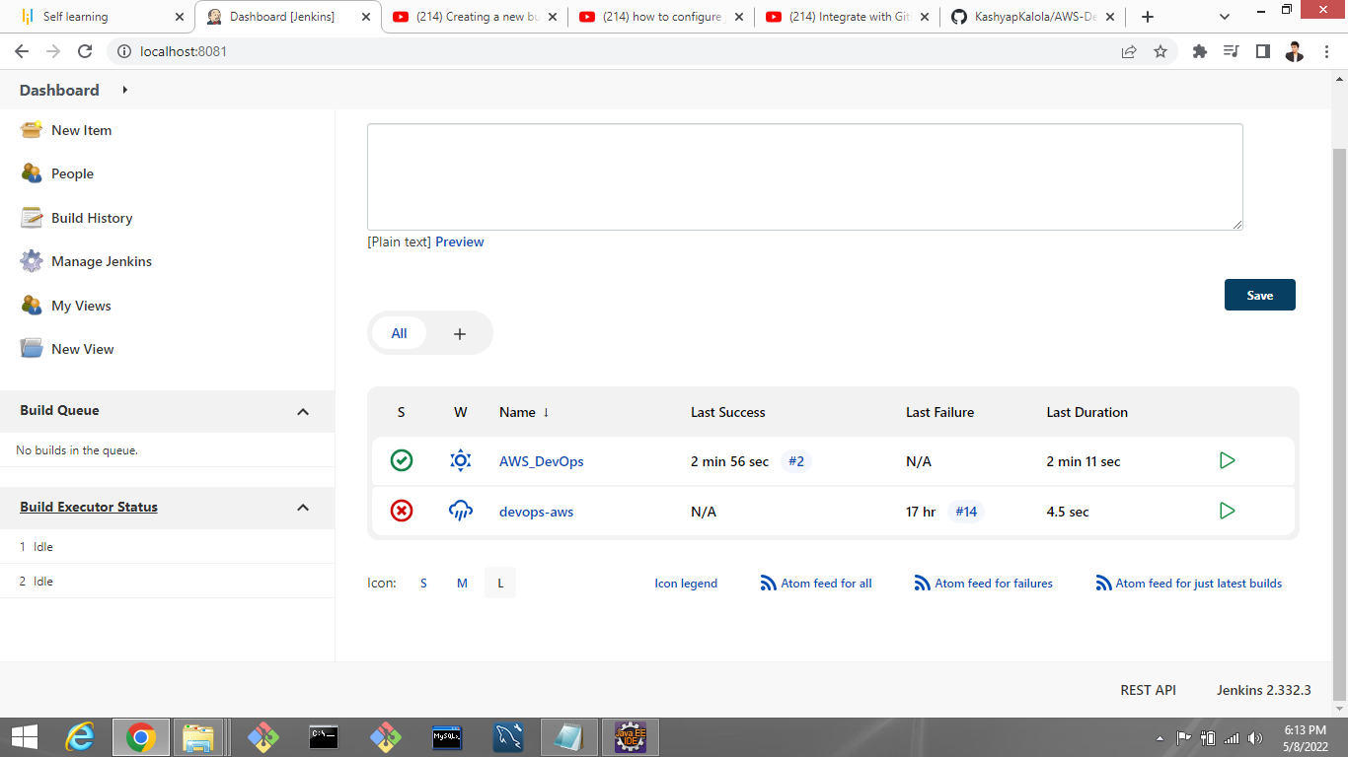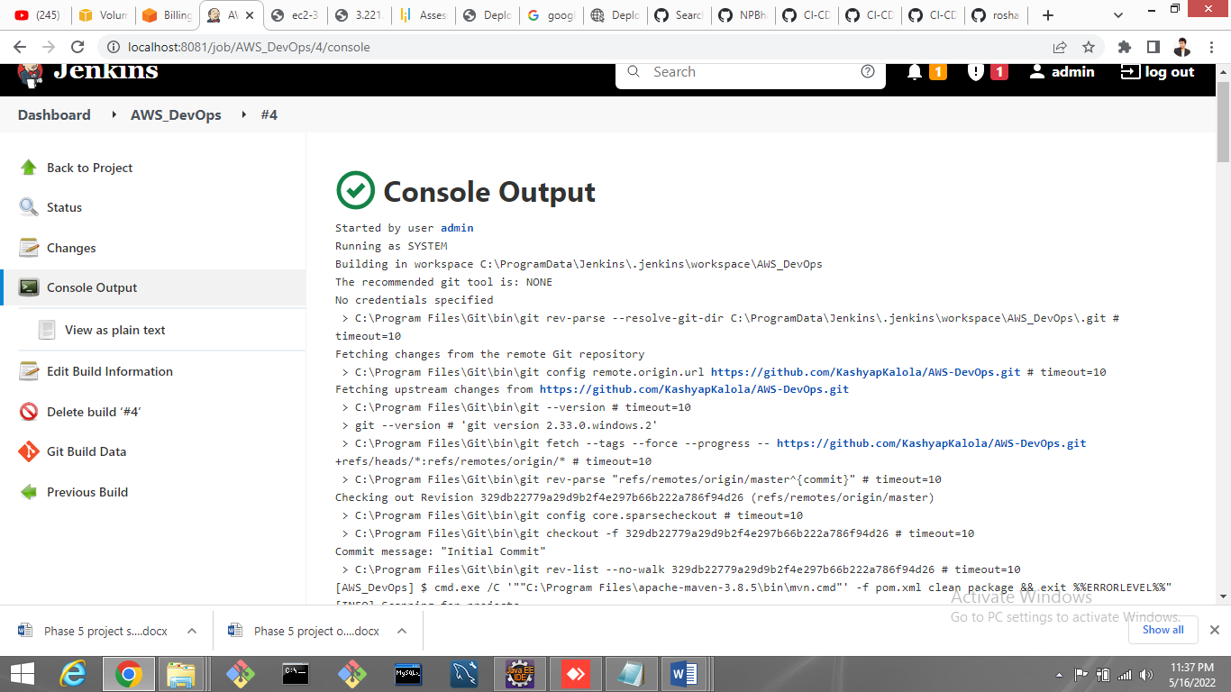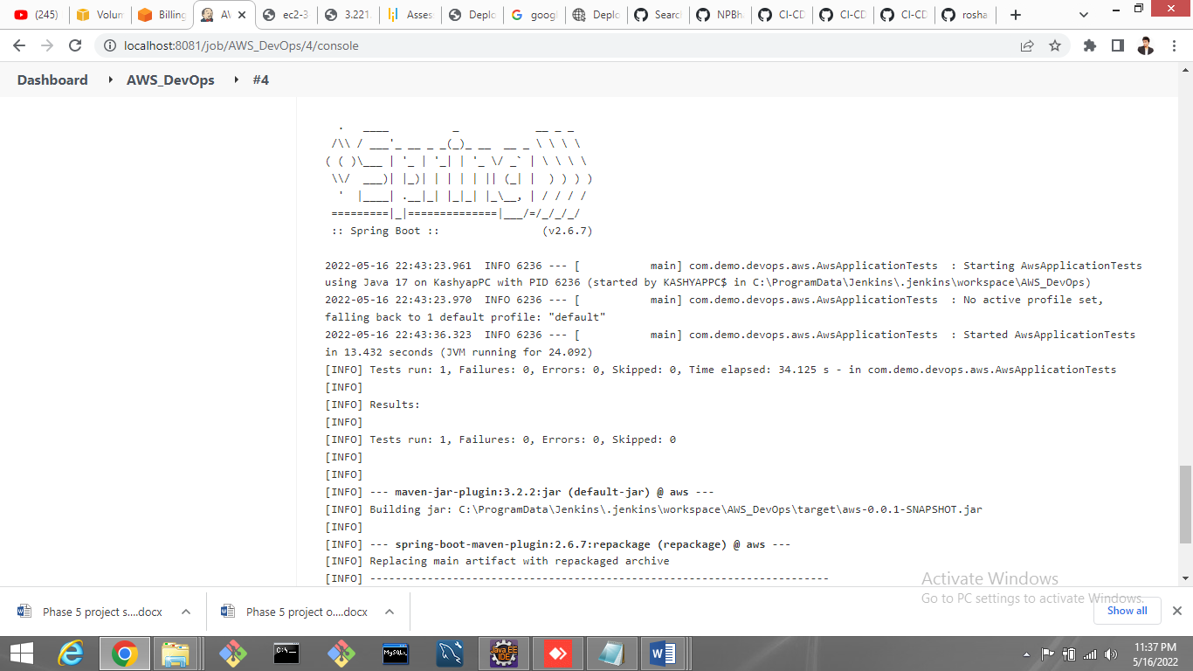.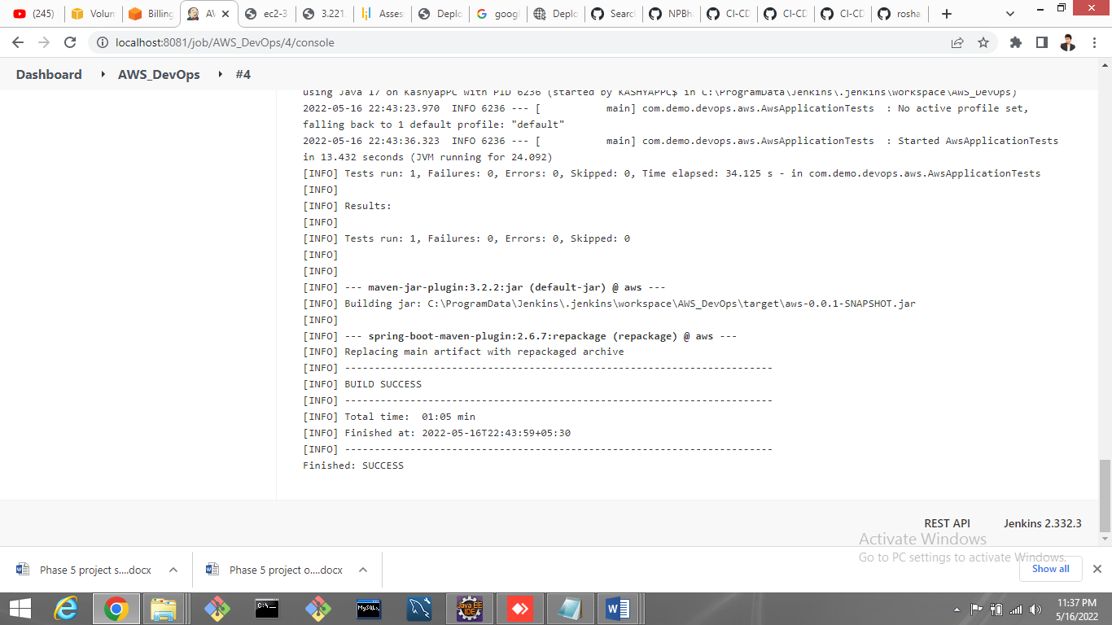

Create Elastic BeanStalk(EC2 Instance and S3 bucket) :-

Elastic Beanstalk automatically handles the deployment, from capacity provisioning, load balancing, auto-scaling to application health monitoring. At the same time, you retain full control over the AWS resources powering your application and can access the underlying resources at any time.

AWS Elastic Beanstalk allows to quickly deploy applications and services without having to worry about configuring underlying resources, services, operating systems or web servers.

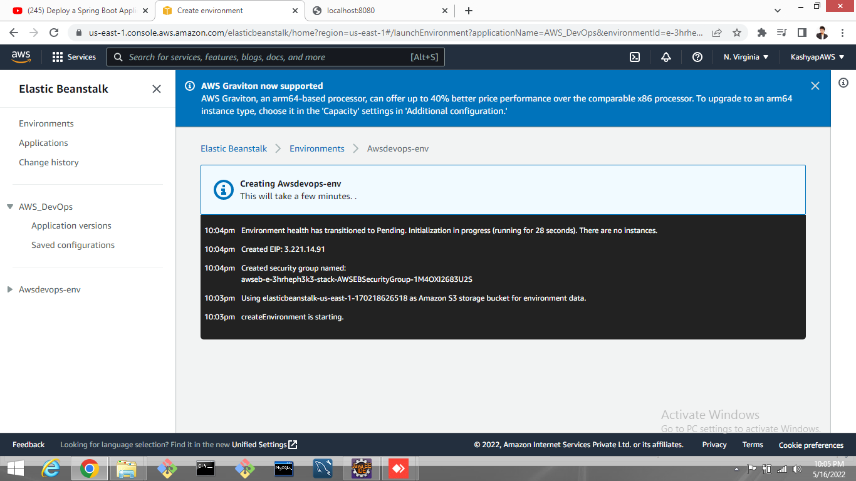.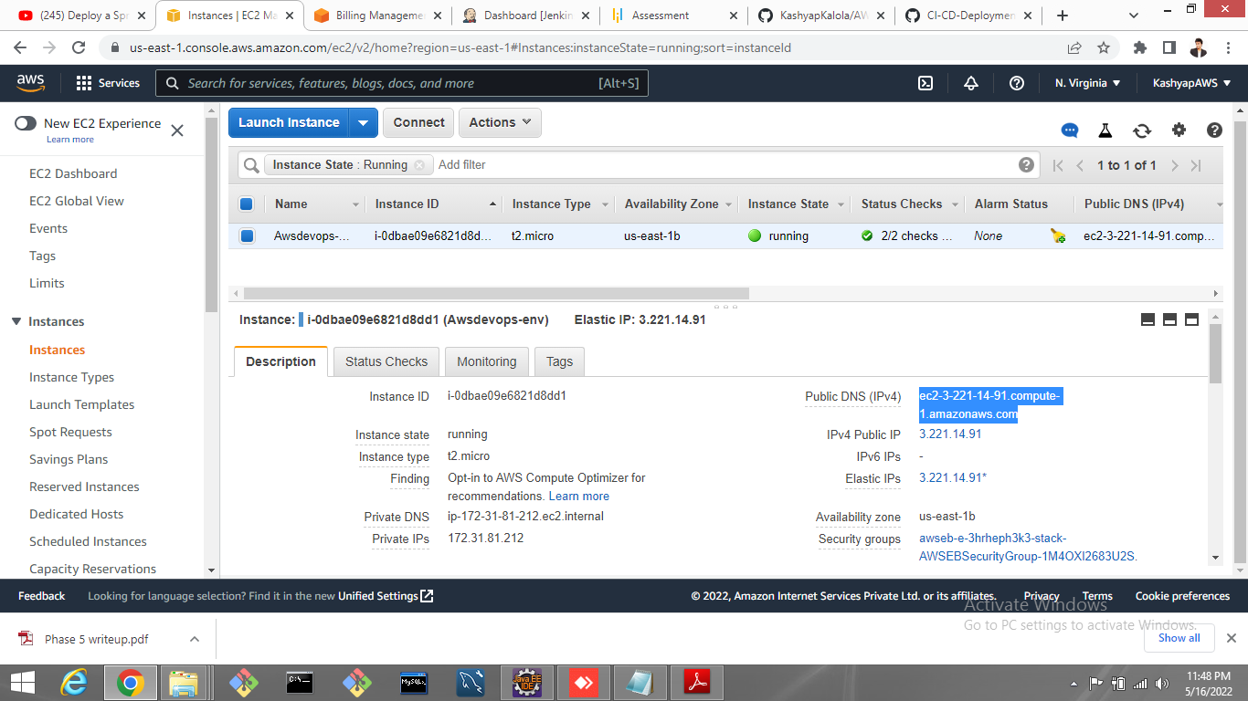.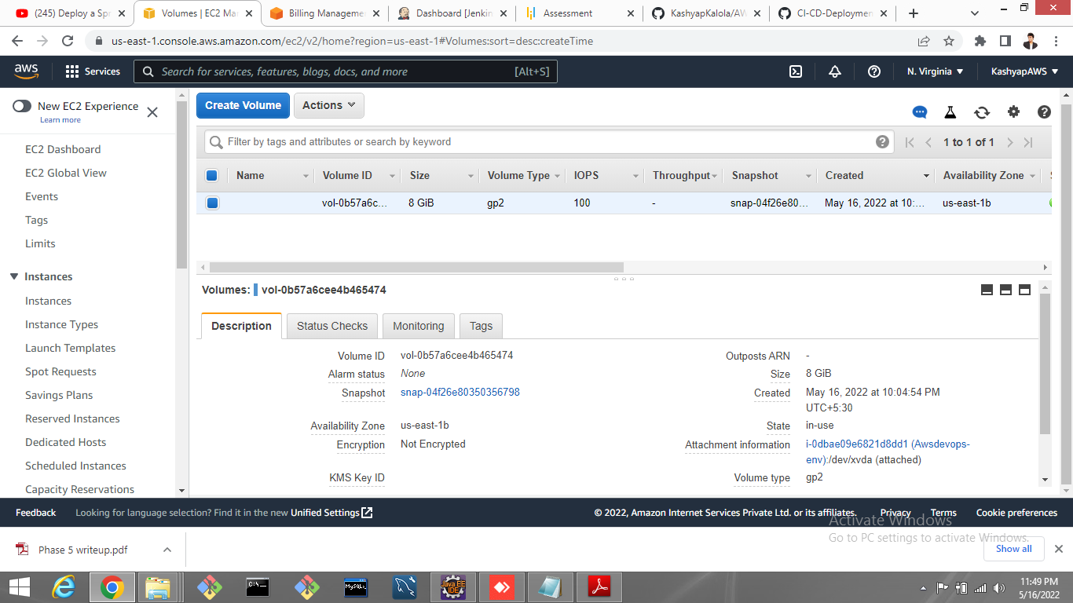.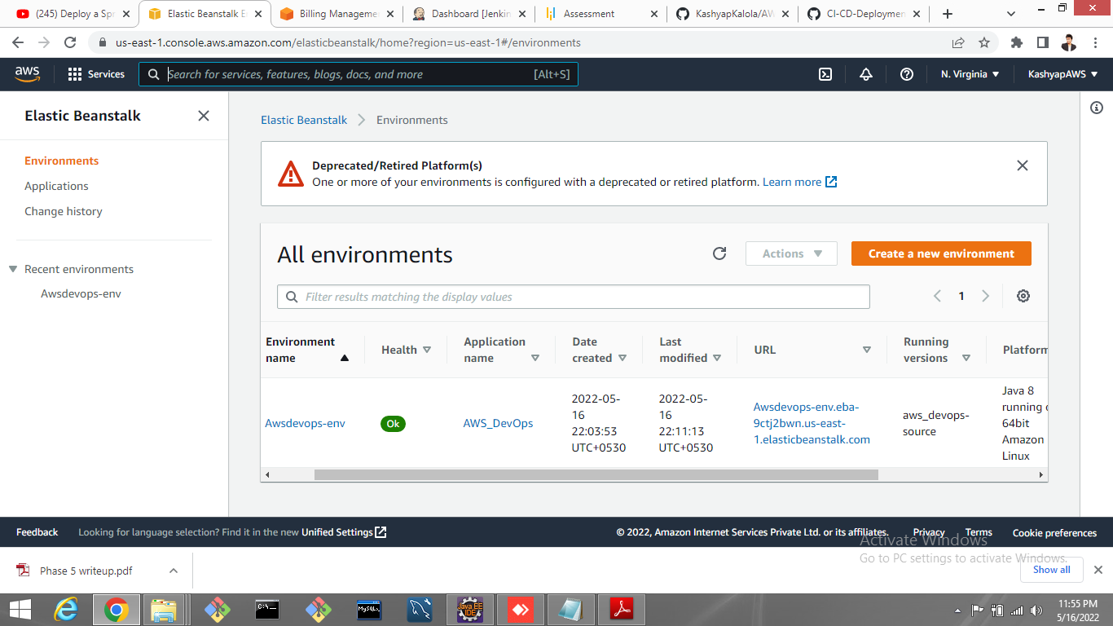

Run SpringBoot Application in EC2 Instance :-

Create Elastic BeanStalk and upload jar file and set all required configuaration and run that application on EC2 instance using it’s public domain Name and piublic IP address..

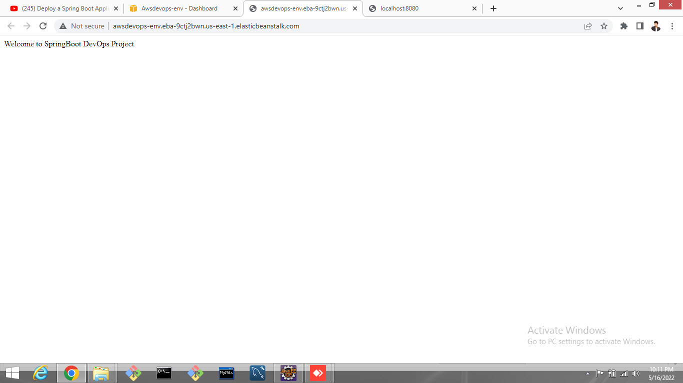.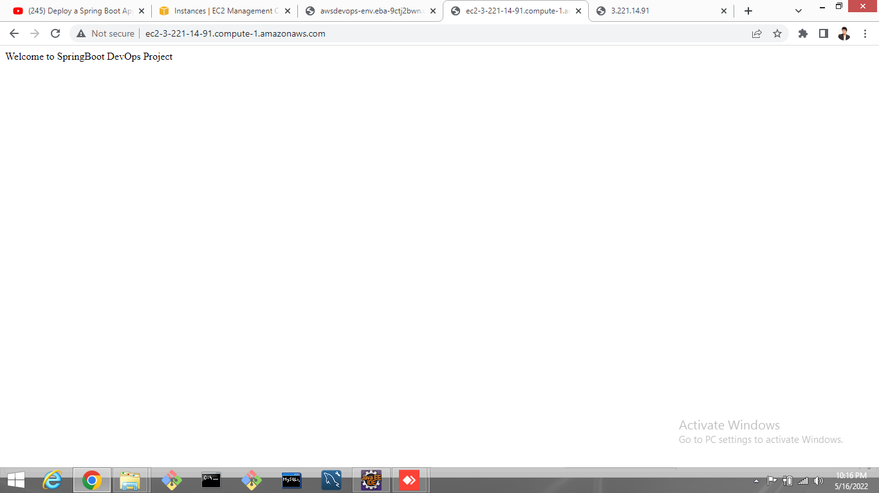

**Source codes**

AwsApplication.java :-

package com.demo.devops.aws;

import org.springframework.boot.SpringApplication;

import org.springframework.boot.autoconfigure.SpringBootApplication;

import org.springframework.web.bind.annotation.GetMapping;

import org.springframework.web.bind.annotation.RestController;

@RestController

@SpringBootApplication

public class AwsApplication {

public static void main(String[] args) {

SpringApplication.run(AwsApplication.class, args);

}

@GetMapping("/")

public String getMessage() {

return "Welcome to SpringBoot DevOps Project";

}

}

Aws/pom.xml:-

<?xml version=*"1.0"* encoding=*"UTF-8"*?>

<project xmlns=*"http://maven.apache.org/POM/4.0.0"* xmlns:xsi=*"http://www.w3.org/2001/XMLSchema-instance"*

xsi:schemaLocation=*"http://maven.apache.org/POM/4.0.0 https://maven.apache.org/xsd/maven-4.0.0.xsd"*>

<modelVersion>4.0.0</modelVersion>

<parent>

<groupId>org.springframework.boot</groupId>

<artifactId>spring-boot-starter-parent</artifactId>

<version>2.6.7</version>

<relativePath/> <!-- lookup parent from repository -->

</parent>

<groupId>com.demo.devops</groupId>

<artifactId>aws</artifactId>

<version>0.0.1-SNAPSHOT</version>

<name>aws</name>

<description>CI/CD Jenkins AWS</description>

<properties>

<java.version>1.8</java.version>

</properties>

<dependencies>

<dependency>

<groupId>org.springframework.boot</groupId>

<artifactId>spring-boot-starter-web</artifactId>

</dependency>

<dependency>

<groupId>org.springframework.boot</groupId>

<artifactId>spring-boot-starter-test</artifactId>

<scope>test</scope>

</dependency>

</dependencies>

<build>

<plugins>

<plugin>

<groupId>org.springframework.boot</groupId>

<artifactId>spring-boot-maven-plugin</artifactId>

</plugin>

</plugins>

</build>

</project>

**Console Output**

Started by user [admin](http://localhost:8081/user/admin)

Running as SYSTEM

Building in workspace C:\ProgramData\Jenkins\.jenkins\workspace\AWS_DevOps

The recommended git tool is: NONE

No credentials specified

> C:\Program Files\Git\bin\git rev-parse --resolve-git-dir C:\ProgramData\Jenkins\.jenkins\workspace\AWS_DevOps\.git # timeout=10

Fetching changes from the remote Git repository

> C:\Program Files\Git\bin\git config remote.origin.url <https://github.com/KashyapKalola/AWS-DevOps.git> # timeout=10

Fetching upstream changes from <https://github.com/KashyapKalola/AWS-DevOps.git>

> C:\Program Files\Git\bin\git --version # timeout=10

> git --version # 'git version 2.33.0.windows.2'

> C:\Program Files\Git\bin\git fetch --tags --force --progress -- <https://github.com/KashyapKalola/AWS-DevOps.git> +refs/heads/*:refs/remotes/origin/* # timeout=10

> C:\Program Files\Git\bin\git rev-parse "refs/remotes/origin/master^{commit}" # timeout=10

Checking out Revision 329db22779a29d9b2f4e297b66b222a786f94d26 (refs/remotes/origin/master)

> C:\Program Files\Git\bin\git config core.sparsecheckout # timeout=10

> C:\Program Files\Git\bin\git checkout -f 329db22779a29d9b2f4e297b66b222a786f94d26 # timeout=10

Commit message: "Initial Commit"

> C:\Program Files\Git\bin\git rev-list --no-walk 329db22779a29d9b2f4e297b66b222a786f94d26 # timeout=10

[AWS_DevOps] $ cmd.exe /C '""C:\Program Files\apache-maven-3.8.5\bin\mvn.cmd"' -f pom.xml clean package && exit %%ERRORLEVEL%%"

[INFO] Scanning for projects...

[INFO]

[INFO] ------------------------< com.demo.devops:aws >-------------------------

[INFO] Building aws 0.0.1-SNAPSHOT

[INFO] --------------------------------[ jar ]---------------------------------

[INFO]

[INFO] **--- maven-clean-plugin:3.1.0:clean (default-clean) @ aws ---**

[INFO] Deleting C:\ProgramData\Jenkins\.jenkins\workspace\AWS_DevOps\target

[INFO]

[INFO] **--- maven-resources-plugin:3.2.0:resources (default-resources) @ aws ---**

[INFO] Using 'UTF-8' encoding to copy filtered resources.

[INFO] Using 'UTF-8' encoding to copy filtered properties files.

[INFO] Copying 1 resource

[INFO] Copying 0 resource

[INFO]

[INFO] **--- maven-compiler-plugin:3.8.1:compile (default-compile) @ aws ---**

[INFO] Changes detected - recompiling the module!

[INFO] Compiling 1 source file to C:\ProgramData\Jenkins\.jenkins\workspace\AWS_DevOps\target\classes

[INFO]

[INFO] **--- maven-resources-plugin:3.2.0:testResources (default-testResources) @ aws ---**

[INFO] Using 'UTF-8' encoding to copy filtered resources.

[INFO] Using 'UTF-8' encoding to copy filtered properties files.

[INFO] skip non existing resourceDirectory C:\ProgramData\Jenkins\.jenkins\workspace\AWS_DevOps\src\test\resources

[INFO]

[INFO] **--- maven-compiler-plugin:3.8.1:testCompile (default-testCompile) @ aws ---**

[INFO] Changes detected - recompiling the module!

[INFO] Compiling 1 source file to C:\ProgramData\Jenkins\.jenkins\workspace\AWS_DevOps\target\test-classes

[INFO]

[INFO] **--- maven-surefire-plugin:2.22.2:test (default-test) @ aws ---**

[INFO]

[INFO] -------------------------------------------------------

[INFO] T E S T S

[INFO] -------------------------------------------------------

[INFO] Running com.demo.devops.aws.AwsApplicationTests

22:43:20.952 [main] DEBUG org.springframework.test.context.BootstrapUtils - Instantiating CacheAwareContextLoaderDelegate from class [org.springframework.test.context.cache.DefaultCacheAwareContextLoaderDelegate]

22:43:21.024 [main] DEBUG org.springframework.test.context.BootstrapUtils - Instantiating BootstrapContext using constructor [public org.springframework.test.context.support.DefaultBootstrapContext(java.lang.Class,org.springframework.test.context.CacheAwareContextLoaderDelegate)]

22:43:21.126 [main] DEBUG org.springframework.test.context.BootstrapUtils - Instantiating TestContextBootstrapper for test class [com.demo.devops.aws.AwsApplicationTests] from class [org.springframework.boot.test.context.SpringBootTestContextBootstrapper]

22:43:21.244 [main] INFO org.springframework.boot.test.context.SpringBootTestContextBootstrapper - Neither @ContextConfiguration nor @ContextHierarchy found for test class [com.demo.devops.aws.AwsApplicationTests], using SpringBootContextLoader

22:43:21.289 [main] DEBUG org.springframework.test.context.support.AbstractContextLoader - Did not detect default resource location for test class [com.demo.devops.aws.AwsApplicationTests]: class path resource [com/demo/devops/aws/AwsApplicationTests-context.xml] does not exist

22:43:21.290 [main] DEBUG org.springframework.test.context.support.AbstractContextLoader - Did not detect default resource location for test class [com.demo.devops.aws.AwsApplicationTests]: class path resource [com/demo/devops/aws/AwsApplicationTestsContext.groovy] does not exist

22:43:21.290 [main] INFO org.springframework.test.context.support.AbstractContextLoader - Could not detect default resource locations for test class [com.demo.devops.aws.AwsApplicationTests]: no resource found for suffixes {-context.xml, Context.groovy}.

22:43:21.291 [main] INFO org.springframework.test.context.support.AnnotationConfigContextLoaderUtils - Could not detect default configuration classes for test class [com.demo.devops.aws.AwsApplicationTests]: AwsApplicationTests does not declare any static, non-private, non-final, nested classes annotated with @Configuration.

22:43:21.698 [main] DEBUG org.springframework.test.context.support.ActiveProfilesUtils - Could not find an 'annotation declaring class' for annotation type [org.springframework.test.context.ActiveProfiles] and class [com.demo.devops.aws.AwsApplicationTests]

22:43:22.057 [main] DEBUG org.springframework.context.annotation.ClassPathScanningCandidateComponentProvider - Identified candidate component class: file [C:\ProgramData\Jenkins\.jenkins\workspace\AWS_DevOps\target\classes\com\demo\devops\aws\AwsApplication.class]

22:43:22.059 [main] INFO org.springframework.boot.test.context.SpringBootTestContextBootstrapper - Found @SpringBootConfiguration com.demo.devops.aws.AwsApplication for test class com.demo.devops.aws.AwsApplicationTests

22:43:22.617 [main] DEBUG org.springframework.boot.test.context.SpringBootTestContextBootstrapper - @TestExecutionListeners is not present for class [com.demo.devops.aws.AwsApplicationTests]: using defaults.

22:43:22.618 [main] INFO org.springframework.boot.test.context.SpringBootTestContextBootstrapper - Loaded default TestExecutionListener class names from location [META-INF/spring.factories]: [org.springframework.boot.test.mock.mockito.MockitoTestExecutionListener, org.springframework.boot.test.mock.mockito.ResetMocksTestExecutionListener, org.springframework.boot.test.autoconfigure.restdocs.RestDocsTestExecutionListener, org.springframework.boot.test.autoconfigure.web.client.MockRestServiceServerResetTestExecutionListener, org.springframework.boot.test.autoconfigure.web.servlet.MockMvcPrintOnlyOnFailureTestExecutionListener, org.springframework.boot.test.autoconfigure.web.servlet.WebDriverTestExecutionListener, org.springframework.boot.test.autoconfigure.webservices.client.MockWebServiceServerTestExecutionListener, org.springframework.test.context.web.ServletTestExecutionListener, org.springframework.test.context.support.DirtiesContextBeforeModesTestExecutionListener, org.springframework.test.context.event.ApplicationEventsTestExecutionListener, org.springframework.test.context.support.DependencyInjectionTestExecutionListener, org.springframework.test.context.support.DirtiesContextTestExecutionListener, org.springframework.test.context.transaction.TransactionalTestExecutionListener, org.springframework.test.context.jdbc.SqlScriptsTestExecutionListener, org.springframework.test.context.event.EventPublishingTestExecutionListener]

22:43:22.683 [main] DEBUG org.springframework.boot.test.context.SpringBootTestContextBootstrapper - Skipping candidate TestExecutionListener [org.springframework.test.context.transaction.TransactionalTestExecutionListener] due to a missing dependency. Specify custom listener classes or make the default listener classes and their required dependencies available. Offending class: [org/springframework/transaction/interceptor/TransactionAttributeSource]

22:43:22.685 [main] DEBUG org.springframework.boot.test.context.SpringBootTestContextBootstrapper - Skipping candidate TestExecutionListener [org.springframework.test.context.jdbc.SqlScriptsTestExecutionListener] due to a missing dependency. Specify custom listener classes or make the default listener classes and their required dependencies available. Offending class: [org/springframework/transaction/interceptor/TransactionAttribute]

22:43:22.685 [main] INFO org.springframework.boot.test.context.SpringBootTestContextBootstrapper - Using TestExecutionListeners: [org.springframework.test.context.web.ServletTestExecutionListener@455b6df1, org.springframework.test.context.support.DirtiesContextBeforeModesTestExecutionListener@4ddbbdf8, org.springframework.test.context.event.ApplicationEventsTestExecutionListener@3f67593e, org.springframework.boot.test.mock.mockito.MockitoTestExecutionListener@1ab06251, org.springframework.boot.test.autoconfigure.SpringBootDependencyInjectionTestExecutionListener@41ab013, org.springframework.test.context.support.DirtiesContextTestExecutionListener@14bee915, org.springframework.test.context.event.EventPublishingTestExecutionListener@1115ec15, org.springframework.boot.test.mock.mockito.ResetMocksTestExecutionListener@82ea68c, org.springframework.boot.test.autoconfigure.restdocs.RestDocsTestExecutionListener@59e505b2, org.springframework.boot.test.autoconfigure.web.client.MockRestServiceServerResetTestExecutionListener@3af0a9da, org.springframework.boot.test.autoconfigure.web.servlet.MockMvcPrintOnlyOnFailureTestExecutionListener@43b9fd5, org.springframework.boot.test.autoconfigure.web.servlet.WebDriverTestExecutionListener@79dc5318, org.springframework.boot.test.autoconfigure.webservices.client.MockWebServiceServerTestExecutionListener@8e50104]

22:43:22.690 [main] DEBUG org.springframework.test.context.support.AbstractDirtiesContextTestExecutionListener - Before test class: context [DefaultTestContext@ae3540e testClass = AwsApplicationTests, testInstance = [null], testMethod = [null], testException = [null], mergedContextConfiguration = [WebMergedContextConfiguration@600b9d27 testClass = AwsApplicationTests, locations = '{}', classes = '{class com.demo.devops.aws.AwsApplication}', contextInitializerClasses = '[]', activeProfiles = '{}', propertySourceLocations = '{}', propertySourceProperties = '{org.springframework.boot.test.context.SpringBootTestContextBootstrapper=true}', contextCustomizers = set[org.springframework.boot.test.context.filter.ExcludeFilterContextCustomizer@378542de, org.springframework.boot.test.json.DuplicateJsonObjectContextCustomizerFactory$DuplicateJsonObjectContextCustomizer@11bd0f3b, org.springframework.boot.test.mock.mockito.MockitoContextCustomizer@0, org.springframework.boot.test.web.client.TestRestTemplateContextCustomizer@b62d79, org.springframework.boot.test.autoconfigure.actuate.metrics.MetricsExportContextCustomizerFactory$DisableMetricExportContextCustomizer@1cbb87f3, org.springframework.boot.test.autoconfigure.properties.PropertyMappingContextCustomizer@0, org.springframework.boot.test.autoconfigure.web.servlet.WebDriverContextCustomizerFactory$Customizer@50b5ac82, org.springframework.boot.test.context.SpringBootTestArgs@1, org.springframework.boot.test.context.SpringBootTestWebEnvironment@2d6eabae], resourceBasePath = 'src/main/webapp', contextLoader = 'org.springframework.boot.test.context.SpringBootContextLoader', parent = [null]], attributes = map['org.springframework.test.context.web.ServletTestExecutionListener.activateListener' -> true]], class annotated with @DirtiesContext [false] with mode [null].

. ____ _ __ _ _

/\\ / ___'_ __ _ _(_)_ __ __ _ \ \ \ \

( ( )\___ | '_ | '_| | '_ \/ _` | \ \ \ \

\\/ ___)| |_)| | | | | || (_| | ) ) ) )

' |____| .__|_| |_|_| |_\__, | / / / /

=========|_|==============|___/=/_/_/_/

:: Spring Boot :: (v2.6.7)

2022-05-16 22:43:23.961 INFO 6236 --- [ main] com.demo.devops.aws.AwsApplicationTests : Starting AwsApplicationTests using Java 17 on KashyapPC with PID 6236 (started by KASHYAPPC$ in C:\ProgramData\Jenkins\.jenkins\workspace\AWS_DevOps)

2022-05-16 22:43:23.970 INFO 6236 --- [ main] com.demo.devops.aws.AwsApplicationTests : No active profile set, falling back to 1 default profile: "default"

2022-05-16 22:43:36.323 INFO 6236 --- [ main] com.demo.devops.aws.AwsApplicationTests : Started AwsApplicationTests in 13.432 seconds (JVM running for 24.092)

[INFO] Tests run: 1, Failures: 0, Errors: 0, Skipped: 0, Time elapsed: 34.125 s - in com.demo.devops.aws.AwsApplicationTests

[INFO]

[INFO] Results:

[INFO]

[INFO] Tests run: 1, Failures: 0, Errors: 0, Skipped: 0

[INFO]

[INFO]

[INFO] **--- maven-jar-plugin:3.2.2:jar (default-jar) @ aws ---**

[INFO] Building jar: C:\ProgramData\Jenkins\.jenkins\workspace\AWS_DevOps\target\aws-0.0.1-SNAPSHOT.jar

[INFO]

[INFO] **--- spring-boot-maven-plugin:2.6.7:repackage (repackage) @ aws ---**

[INFO] Replacing main artifact with repackaged archive

[INFO] ------------------------------------------------------------------------

[INFO] BUILD SUCCESS

[INFO] ------------------------------------------------------------------------

[INFO] Total time: 01:05 min

[INFO] Finished at: 2022-05-16T22:43:59+05:30

[INFO] ------------------------------------------------------------------------

Finished: SUCCESS

**Future Scope**

* Can be added more piple and build paralle jobs.
* Can be run other application in AMI(Amazon Machine Image)
* An be use different Progarmming language for different functionality and build the same on EC2 instance

--------------------------------------THNAK YOU-----------------------------------------